Diversity Posttest (High School)

Science is easier to understand if you can make connections between what you know now and the new ideas you are studying. This is a test that will help us know what you know now.

Please answer these questions as carefully and completely as you can. If you aren’t sure of the answer, please write any thoughts that you have. If you can help us to understand how you think about these questions, then we can do a better job of explaining science in ways that make sense to you.

Please put your initials (not your full name) in these boxes:
Also put your initials on the top of each page.
First Middle Last
Date _______________________

Class ______________________ Teacher ____________________________

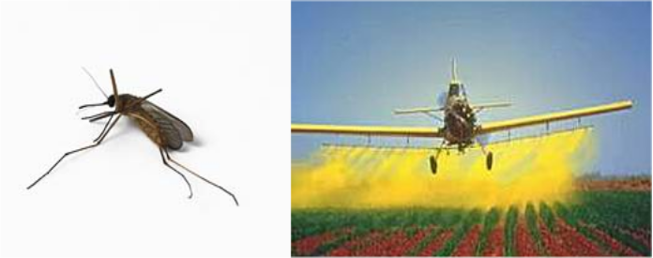

1. Farmers often use pesticides to help prevent insects from eating their crops. Over time, the insects slowly become resistant to these pesticides, and so the farmers have to use different pesticides to protect their crops. Tell a story about how the insects become resistant to the pesticides.

2. Put the following items in the boxes below, going from the smallest (on the left) to the largest (on the right). Be sure to include all the terms.

Population
Gene
Species
DNA
Ecosystem
Dog
Chromosome

Smallest Largest
atom |  |  |  |  |  |  |  | planet

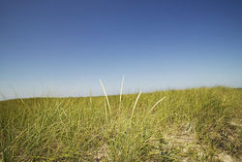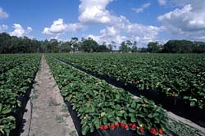
Wild Grassland Strawberry Field

3. A wild grassland is turned into a managed strawberry field. In the boxes below, describe what happened to the plant, animal and soil communities as a result of this transformation.

What happened to the plant community?

What happened to the animal community?

What happened to the soil community?

4. When Europeans first came to Peru, the found that the Peruvians were growing a crop that they had never seen before: potatoes. Each Peruvian field contained many types of potatoes, as shown in the picture on the left. The Europeans selected the biggest and best type of potatoes (shown in the picture on the right), took that back to Europe, and planted fields containing just this one type of potato.

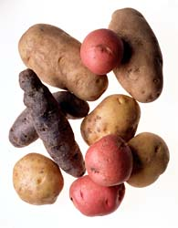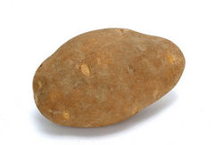
Peruvian fields European fields

What are the advantages and disadvantages of these two ways of growing potatoes?

 | Peruvian way | European way
Advantages
Disadvantages

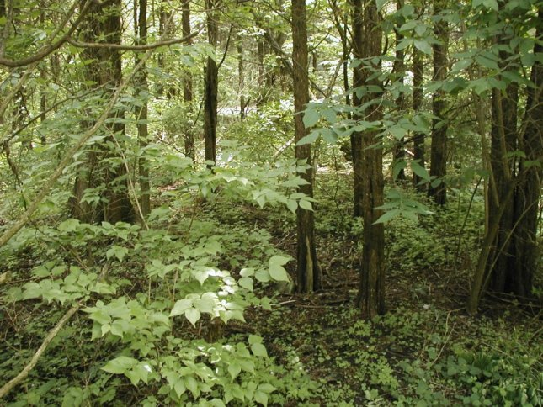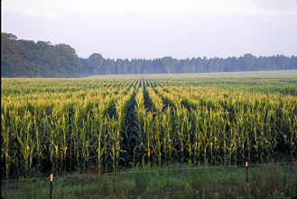

Forest Corn Field

5a. Above are pictures of a Michigan forest and a Michigan corn field. Explain why you think these places are similar and different:

Ways they are similar:

Ways they are different:

5b. Do you think more kinds of living things are living in the forest or in the cornfield?

Circle one: | Forest | Cornfield | The same in both

Explain why you think this:

5c. What differences do you think you would see in the soils of the corn field and the soils of the forest? An example is given for you

Difference | Forest soil | Corn field soil | Explanation
Type of plant material | Tree leaves, bark, twigs | Corn stems and leaves | When trees and plants die or leaves fall in a forest, they become part of the soil while dead corn plants become part of the soil in the corn field

5d. A farmer decided to cut down the forest, remove all of the tree stumps and plant corn, but the corn did not grow very well during the first year after cutting down the forest. Why do you think this might happen?

Wild Grassland Strawberry Field

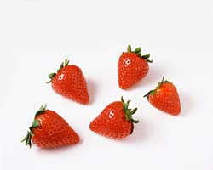
6a. The strawberries in the picture all grew in large field on the same farm, but they all look a little different. Why do you think they all look a little different?

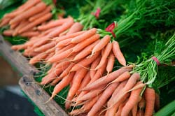
6b. The carrots in the picture all grew in a greenhouse under identical conditions, but they all look a little different. Why do you think they all look a little different?

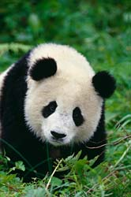
7. There are so few of some endangered species like the giant panda, that many of the remaining individuals live in zoos and wildlife sanctuaries, where scientists try to help endangered species in captive breeding programs. One of the goals of these breeding programs is to try to increase the genetic diversity in the remaining population of pandas.

Why do you think these breeding programs want to increase genetic diversity in the remaining population of pandas?

How could these breeding programs go about increasing genetic diversity in the remaining panda population?

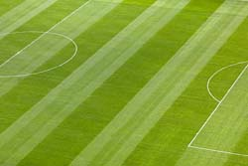

8. To the right is a picture of a soccer field. What would happen if people stop mowing and taking care of the soccer field? In the boxes below describe what the soccer field might look like, and all of the things that might be living there.

 | What might it look like? | What might be living there?
In 1 year
In 10 years
In 100 years

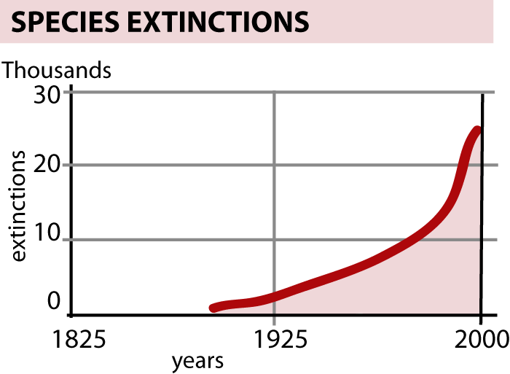
9. The graph to the right shows a rapid increase in the number of species going extinct over the last 100 years. Why do you think more species are going extinct each year?

In the boxes below, describe three possible reasons for the increase in species extinctions and decline in biodiversity.

Reason | How would this cause species to go extinct?
1.

2.

3.

